**Performance Test Report**

**For**

**Execution of**

**Masterdata registrationcenters – 250 users**

Date: 04 June 2020

Author: Gaurav Sharan

**Summary**

This report presents the observations and findings of the load test conducted for a load of 250 users on masterdata registrationcenters API.

The objective of this load test was to observe and record behavior of the application when user load is increased from 150 to 250.

Below are the scenario details:

|  |  |
| --- | --- |
| **Script/Report Name** | Masterdata registrationcentersAPI |
| **Run Date** | 04-June-2020 |
| **Period** | 05:59:39 UTC to 06:51:37 UTC |
| **Number of concurrent users** | 150 to 250 |
| **Ramp up** | 01 user per second |
| **Run Duration** | --- |
| **Ramp down** | NA |

|  |  |  |  |  |  |  |  |
| --- | --- | --- | --- | --- | --- | --- | --- |
| **Label** | **# Samples** | **Average(ms)** | **90% Line(ms)** | **Min(ms)** | **Max(ms)** | **Error %** | **Throughput** |
| TR_masterdata_  registrationcenters_  location_name | 92870 | 1204 | 3239 | 20 | 60010 | 0.00% | 29.79661 |
| TR_masterdata_  registrationcenters | 92976 | 1230 | 3409 | 22 | 39457 | 0.00% | 29.83557 |
| TR_masterdata_  registrationcenters_  centerId | 93143 | 1210 | 3313 | 20 | 42698 | 0.00% | 29.89604 |

The transaction response times observed were as below:

**Performance Test Execution Details**

We have executed JMeter script for masterdata registrationcenters service, which has transactions mentioned in the above table.

Average response time of the APIs is 1.2 sec with error rate 0 %.

**Response Time and TPS Graph:**

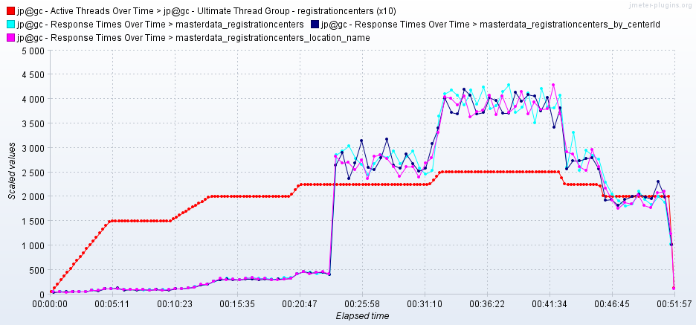

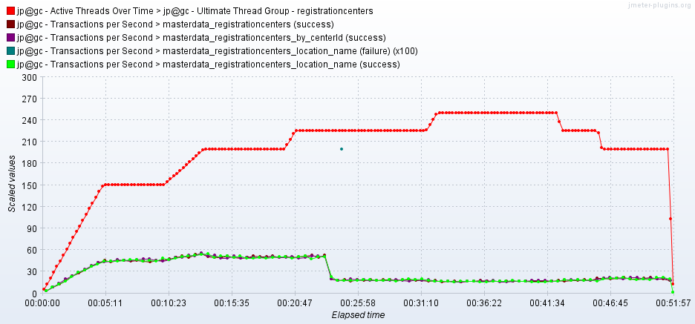

As seen in the graph, response time of the APIs increases from 500 ms when 200 users are there to 2.8 sec when number of users become 225.

Throughput (TPS) of the APIs reduces from 51 to 17 when number of active users becomes 225.